Lab 6.4: Docker Networking with 2 SSHs

This section will show you to use Docker network and its configuration in a container.

This lab has 3 sub-sections:

6.4.1: Create a Centos container and commit it

6.4.2: Create a bridge network and find its IP address

6.4.3: Connect the network from another SSH server

**Step 6.4.1:** Create a Centos container and commit it

Create a Centos Docker container and install net tools.

docker run -it --name centos centos /bin/bash  
yum install -y net-tools

Check the IP address and hostname.

ifconfig  
cat /etc/hosts  
hostname

Exit the container using CTRL+D.

Commit the container to an image (Please refer to the screenshot).

docker commit centos centos-net  
docker images  
docker rm centos

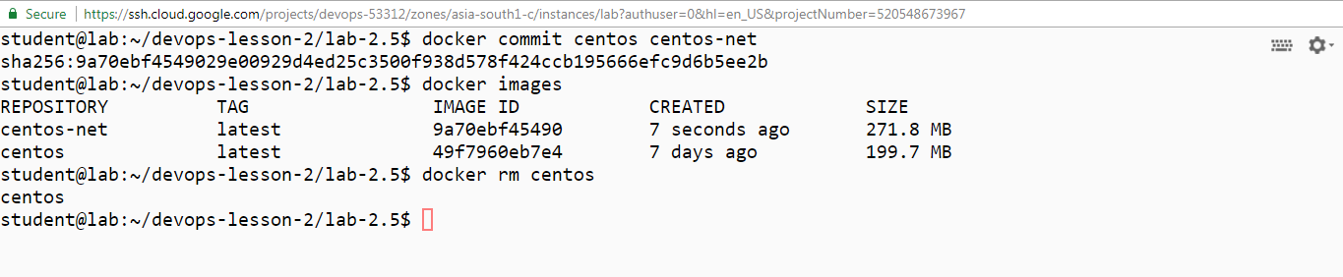

**Step 6.4.2:** Create a bridge network and find its IP address

Create a bridge network and find its IP range.

docker network create exnet  
docker network ls  
docker network inspect exnet

Run the centos container using the new network.

docker run -it --rm --network exnet centos-net /bin/bash

Check the IP address and hostname.

ifconfig  
cat /etc/hosts  
hostname

Exit the container using CTRL+D.

Start a new container using the default network.

docker run -it --rm --name centos centos-net /bin/bash

Check the IP address and hostname.

ifconfig  
cat /etc/hosts  
hostname

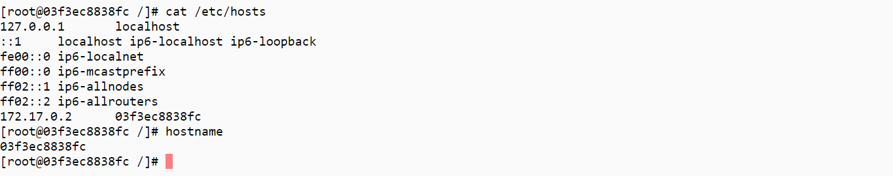

**Step 6.4.3:** Connect the network from another SSH server

From the second SSH window, connect the network to the container.

docker network connect exnet centos

Go back to the running container. You will see that it now has two IP addresses (Please refer to the screenshot).

ifconfig  
cat /etc/hosts  
hostname

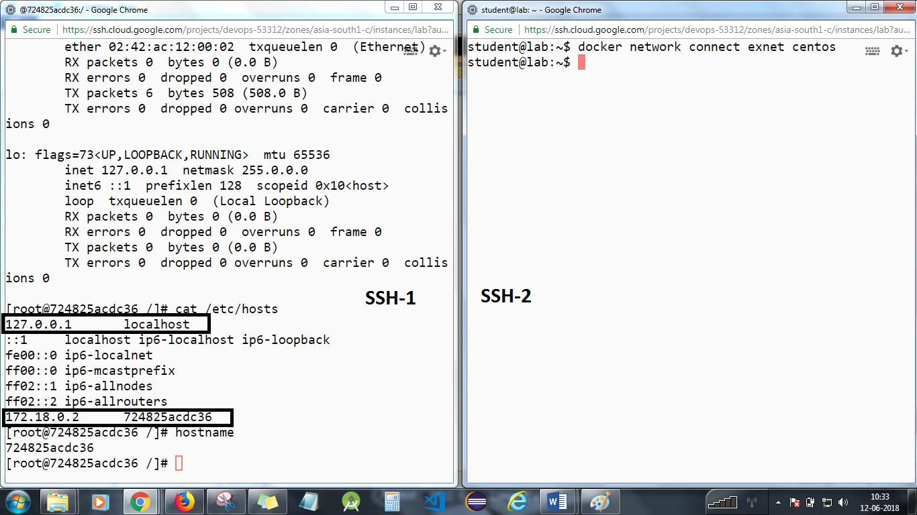

Go to the second SSH window and disconnect the network.

docker network disconnect exnet centos

Go back to the running container and see that it now has one IP address.

ifconfig  
cat /etc/hosts  
hostname

Exit the container using CTRL+D.